**HIND SERIES HELICOPTER**

**Mi-24 HIND**

**Mi-25 HIND D**

**Mi-35 HIND E**

The Mi-24, the first helicopter to enter service with the Russian Air Force as an assault transport and gunship, was developed on the basis of the Mi-8's propulsion system. Additional missions include direct air support, antitank, armed escort, and air to air combat. The helicopter was used extensively in the Afghanistan War, becoming the "signature" weapon of the conflict. The Mi-24 is a close counterpart to the American AH-64 Apache, but unlike this and other Western assault helicopters it is also capable of transporting up to eight troops. The Russians have deployed significant numbers of HINDs in Europe and have exported the HIND to many third world countries.

The five-blade main rotor is mounted on top of fuselage midsection, while short, stubby, weapon-carrying wings are mounted at the fuselage midsection. Two turboshaft engines are mounted above body midsection with two round air intakes located just above the cockpit and exhaust ports on the sides of engines. The Hind A fuselage consists of a large, oval-shaped body with a glassed-in cockpit, tapering at the rear to the tail boom. The Hind D fuselage features nose modification with tandem bubble canopies, and a chin-mounted turret. The swept-back tapered tail fin features a rotor on the right on some models, with tapered flats on a boom just forward of the fin.

External stores are mounted on underwing external stores points. Each wing has three hardpoints for a total of six stations. A representative mix when targeting armor formations would be eight AT-6 ATGMs, 750x 30-mm rounds, and two 57-mm rocket pods. The aircraft can store an additional ammunition basic load in the cargo compartment in lieu of carrying troops. Armored cockpits and titanium rotor head able to withstand 20-mm cannon hits. Every aircraft has an over pressurization system for operation in a NBC environment.

The HIND’s wings provide 22% to 28% of its lift in forward flight. In a steep banking turn at slower airspeeds, the low wing can lose lift while it is maintained on the upper wing, resulting in an excessive roll. This is countered by increasing forward airspeed to increase lift on the lower wing. Because of this characteristic, and the aircraft’s size and weight, it is not easily maneuverable. Therefore they usually attack in pairs or multiple pairs, and from various directions.

**VARIANTS**

Nearly all of the older HIND A, B and C variants have been upgraded or modified to the HIND D or E standard.

* Mi-24D/HIND D: Direct air support.
* Mi-24V/HIND E: Direct air support. Most proliferated version.
* Mi-24P/HIND F: Direct air support. The fixed twin gun cut the turret profile, and empty weight to 8,200 kg, while boosting maximum gross weight to 12,000 kg.
* Mi-24R/HIND G-1: NBC sampling. It has mechanisms to obtain soil and air samples, filter air, and place marker flares.
* Mi-24K/HIND G-2: Photo-recon, and artillery spotting. Has a camera in cabin, gun, rocket pods, but no targeting system.
* Mi-25: Export version of the HIND D.
* Mi-35: Export version of the HIND E. The Mi-35M has a twin barrel 23-mm gun.
* Mi-35P: Export version of the HIND F.

|  |  |
| --- | --- |
| **Specifications** | |
| **Country of Origin** | Russia |
| **Builder** | MIL |
| **Date of Introduction** | 1976 (HIND D) |
| **Role** | Assault, gunship, antitank |
| **Similar Aircraft** | AH-1 Cobra (all models), UH-60 Black Hawk, AH-64 Apache, Mangusta A129 |
| **Blades** | Main rotor: 5 Tail rotor: 3 |
| **Rotor diameter** | Main Rotor : 17.3 meters Tail Rotor: 3.9 meters |
| **Wing span** | 6.5 meters |
| **Length** | Length : 21.6 m (rotors turning) Length : 17.5 m (fuselage) |
| **Height** | 13 ft., 11 in. 6.5 meters (gear extended) |
| **Cargo Compartment Dimensions** | Floor Length: 2.5 meters Width: 1.5 meters Height: 1.2 meters |
| **Weight** | Maximum Gross: 11,500 kg Normal Takeoff: 11,100 kg Empty: 8,500 kg |
| **Fuel** | Internal: 1,840 liters Internal Aux Tank (in cabin): 1,227 liters External Fuel Tank: 500 liters ea. |
| **Engine** | 2 x 2,200 shp Isotov TV-3-117 turbines |
| **Maximum speed** | 168 mph / 335 km/h |
| **Cruising speed** | 295 km/h |
| **Range** | Normal Load: 450 km With Aux Fuel: 950 km |
| **Service Ceiling** | 4,500 meters |
| **Hover** | out of ground effect: 1,500 meters in ground effect : 2,200 meters |
| **Vertical Climb Rate** | 15 m/s |
| **Max G Force** | 1.75 g |
| **Standard Payload** | Internal load: 8 combat troops or 4 litters External weapons load: 1,500 kg External load (no weapons): 2,500 kg |
| **Armament** | 12.7-mm 4x Barrel Machinegun, YaKB-12.7: Range (m): (practical) 1,500 Elevation/Traverse: 20’ up to 60’ down/ 120’ Ammo Type: HEFI, APT, Duplex, DuplexT Rate of Fire (rpm): up to 4,500 (pilot selectable)  30-mm Twin Barrel Cannon, GSh-30K: Range (m): (practical) 4,000 Elevation/Traverse: None (rigidly mounted) Ammo Type: HEFI, HEI, APT, APE, CC Rate of Fire (rpm): 300, or 2,000 to 2,600  • 750 - 1x twin 30-mm gun, or  • 1,470 - 12.7-mm 4 barrel turret gun  • 2-12 - AT-2C or AT-6C Spiral ATGMs  • 2-4 - 80-mm S-8 rocket pods (20 ea.)  • 2-4 - 57-mm S-5 rocket pods (32 ea.)  • 940 - GSh-23L twin 23-mm MG pods  • 4 - 250-kg bombs FAB-250  • 2 - 500-kg bombs  • 500 liters External fuel tanks  Most Probable Armament  • HIND D: Turret-mounted 4-barrel 12.7-mm Gatling type machinegun, 57-mm rockets, AT-2C/ SWATTER ATGMs.  • HIND E: Turret-mounted 4-barrel 12.7-mm Gatling type machinegun or twin barrel 23-mm turret gun, 57-mm rockets, AT-6C/ SPIRAL ATGMs.  • HIND F: Fixed 30-mm twin gun on the right fuselage side, 57-mm rockets, AT-6C/ SPIRAL ATGMs.  Loaded combat troops can fire personal weapons through cabin windows. |
| **Sensors** | FLIR, RWR, laser designator |
| **AVIONICS** | • The ATGM targeting system uses a low-level light TV, a laser designator, FLIR, air data sensor, and a missile guidance transmitter.  • HIND D versions are primarily daytime aircraft only. Some HIND E and Mi-35 series export versions have upgraded night and weather capabilities, better avionics, weather radar, autopilot, HUD, GPS, NVG compatibility, more armor, and an increased weapons load provided by the French company Sextant Avionique. |
| **Survivability** | • Main and tail rotors electrically deiced.  • Infrared signature suppressors can be mounted on engine exhausts.  • Radar warning receivers, IFF, Infrared jammer, rotor brake, chaff and flares.  • Armored cockpit. |
| **Crew** | Two (pilots in tandem cockpits) |
| **Cost** |  |
| **User Countries** | At least 34 countries -- Armenia, Afghanistan, Algeria, Angola, Belarus, Bulgaria, Cambodia, CIS, Cuba, Czech Republic, Ethiopia, Georgia, Germany, Hungary, Iran, Iraq, Libya, Mongolia, Mozambique, Nicaragua, North Korea, Peru, Poland, Slovakia, South Yemen, Syria, Ukraine, Vietnam |

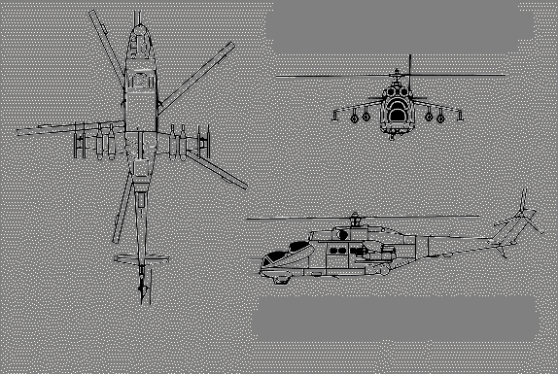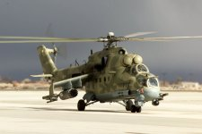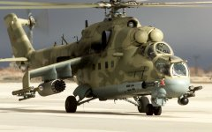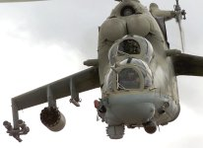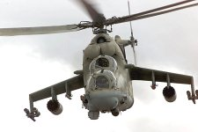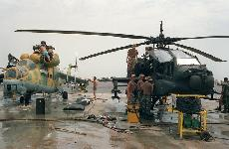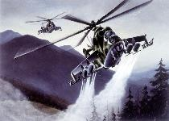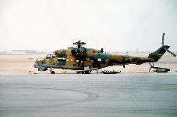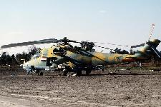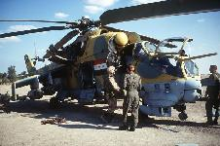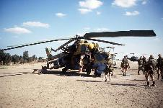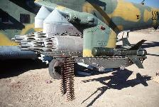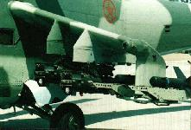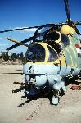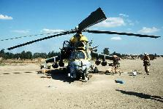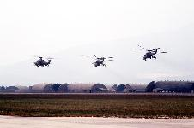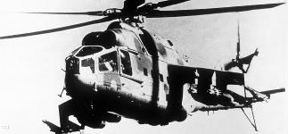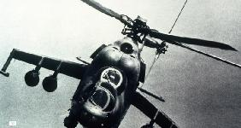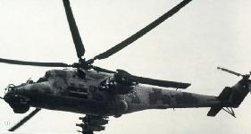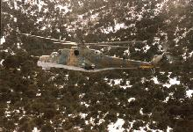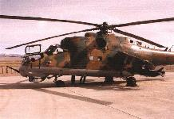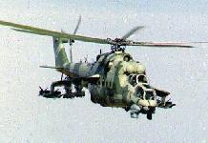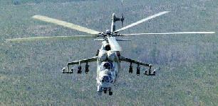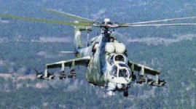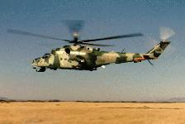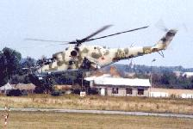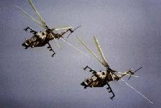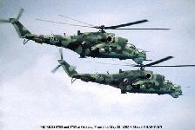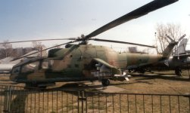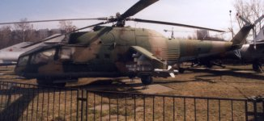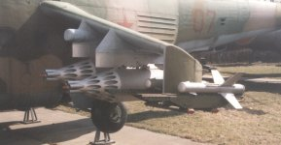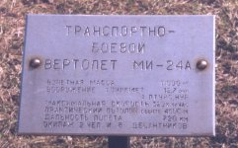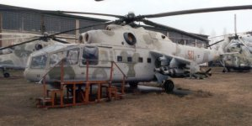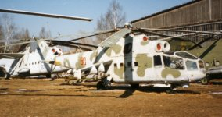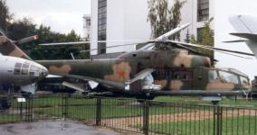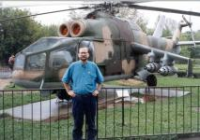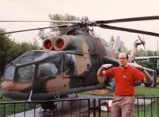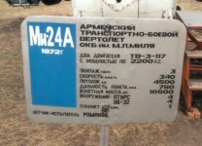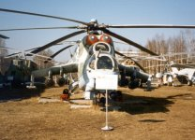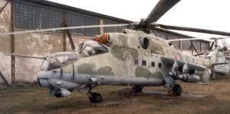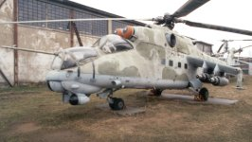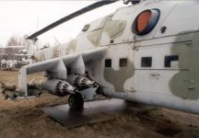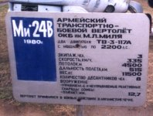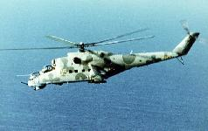

**Sources and Resources**

**http://www.fas.org/man/dod-101/sys/ac/row/mi-24.htm  
Maintained by** [**Webmaster**](mailto:webmaster@fas.org) **Updated Wednesday, August 9, 2000 12:36:30 PM**